1. **Introduction**

**Glancify** is a high-quality product and we make no compromises as per as the heart of the product is concerned. Building quality products require good code and **Glancify** is no exception.

Well written software offers many advantages. It will contain fewer bugs and will run more efficiently than poorly written programs. Since software has a life cycle and much of which revolves around maintenance, it will be easier for the original developers and future keepers of the code to maintain and modify the software as needed.

This document contains the standards and guidelines that the developers are supposed to follow while writing code for the **Glancify** project. Standards are rules which programmers are expected to follow, and they will be enforced through automated systems and manual reviews where automatic check is not applicable. Guidelines can be viewed as suggestions which can help programmers write better software and are optional, but highly recommended.

At some cases, a standard or guideline may vary for different languages and it will be clearly specified in the document. This document will be subject to revisions and the standards will be evolved when needed.

1. **Coding Standards**

**2.1 Indentation**

Indentation is a very important factor for producing readable and maintainable code. It should be used whenever there is a need to –

* Emphasize the body of a control statement such as a loop or a select statement.
* Emphasize the body of a conditional statement.
* Emphasize a new scope block.

JavaScript, CSS and HTML code should use 2 spaces of indentation whereas JSON code should use 1-tab indentation. The above specification is consistent with the JSLint specification.

* 1. **Inline comments**

Inline comment should be used to clearly define what is happening in the code where needed. The more the number of inline comments, the better it is.

**2.3 Functions**

Code should be modular, and the modules should be properly defined such as they are as much independent as possible. Deprecated instructions like GOTO should seldom be used. The Name should be descriptive and should be camelCase.

**2.4 Code files**

Code files should be name in such a way that the purpose of the code in that file can be understood from the name itself.

**2.5 Variable Names**

Variables shall have meaningful names that convey to a casual observer, the intent of its use. Variables shall be initialized prior to its first use. Variables with multiple words should always use an underscore between words.

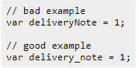

**2.6 Using braces**

Braces should strictly be used even if it is a one-line statement.

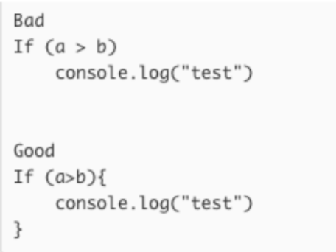

**2.6.1 Opening Brace Location**

Always put the opening brace on the same line as the previous statement.

|  |
| --- |
| Bad Example |
| function func()  {  return  {  "name": "Batman"  };  } |
| Good Example |
| function func () {  return {  "name": "Batman"  };  } |

**2.6.2 Closing Brace Location**

The closing brace should be on the same indent as the original function call.

|  |
| --- |
| Bad Example |
| function func() {  return {  "name": "Batman"  };  } |
| Good Example |
| function func() {  return {  "name": "Batman"  };  } |

1. **Coding Guidelines**
   1. **Line Length**

It is clever idea to keep line length less than 150 character. This will help maintain code readability on small screen sizes. JavaScript code less than 120 chars as then it will be consistent with ESLint spec.

* 1. **Spacing**

The proper use of spaces within a line of code can enhance readability. Good rules of thumb are as follows:

* A keyword followed by a parenthesis should be separated by a space.
* A blank space should appear after each comma in an argument list.
* All binary operators except **.** should be separated from their operands by spaces.

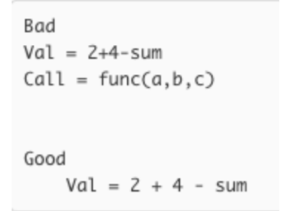

* 1. **Variable Declarations**

Multiple variable declarations in a single line must be separated by space after comma.

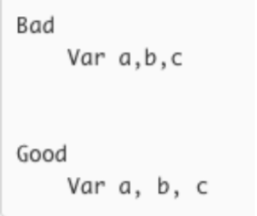

Abbreviations should not be used to avoid confusion.

|  |
| --- |
| Bad Example |
| // delivery note  var delivery_note = 1; |
| Good Example |
| // delivery note  var del_note = 1; |

* 1. **Statements**

Statements should be limited to one per line to avoid complexity and improve code readability. It will also make the code look more consistent w.r.t coding style.

* 1. **Meaningful error messages**

Error messages should be clearly defined with error codes and help messages. This will help to understand the error more clearly as well as help developers locate the error quickly. When possible, they should indicate what the problem is, where the problem occurred, and when the problem occurred.

Error messages should also be logged to standard output to make the easily debuggable by the admin team. Optionally, they can also be recorded in a non-temporary location so that they can be reviewed upon when needed.

* 1. **File Length**

File length (line count) should be kept less than 300 lines. If the file is exceeding that, it is better to break it into 2 or more modules.